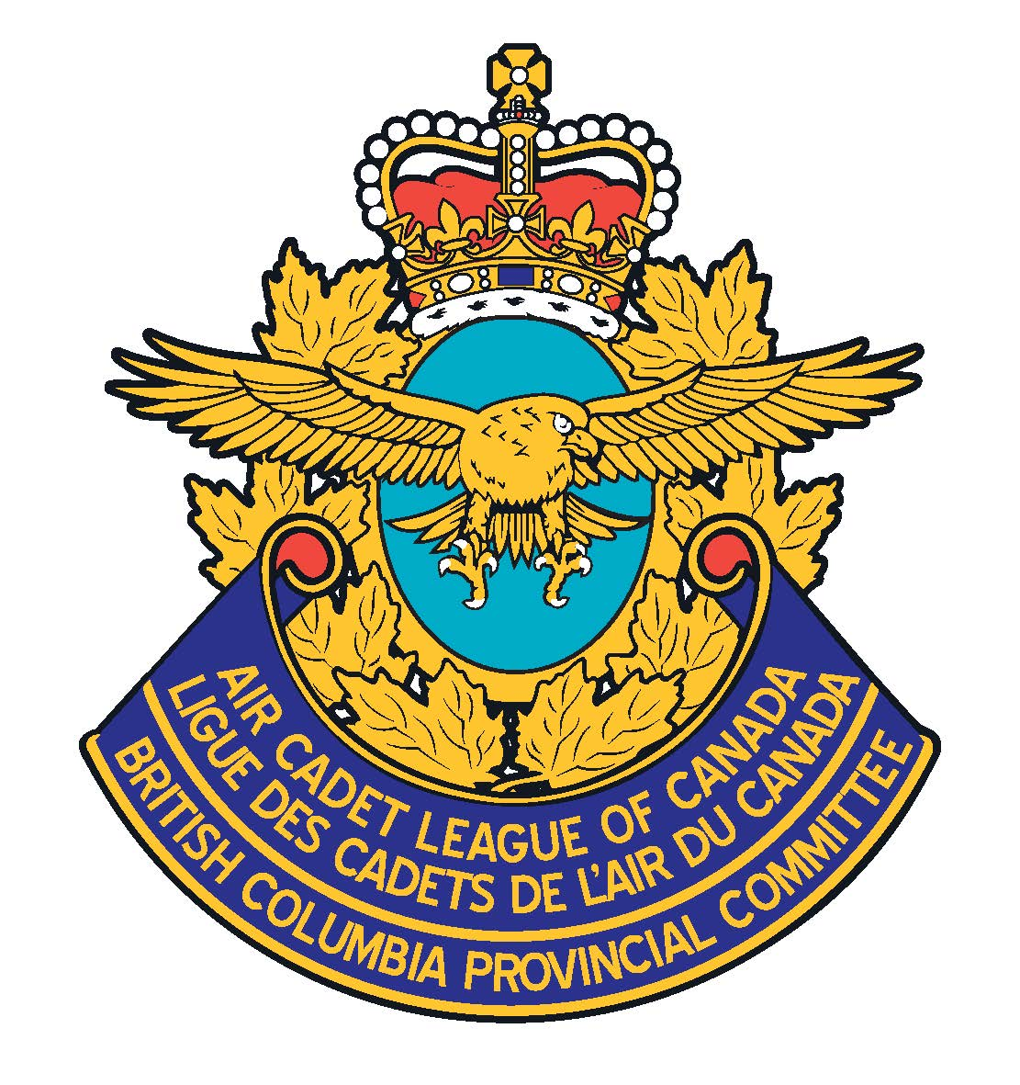
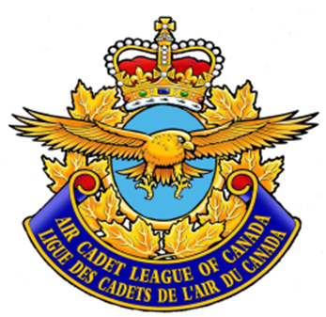

SSC Legal Name

Hereby Presents This

Certificate of Appreciation

To

In Recognition of Outstanding Service to the
Air Cadet League of Canada and the Royal Canadian Air Cadets

SSC Chair
Date:

