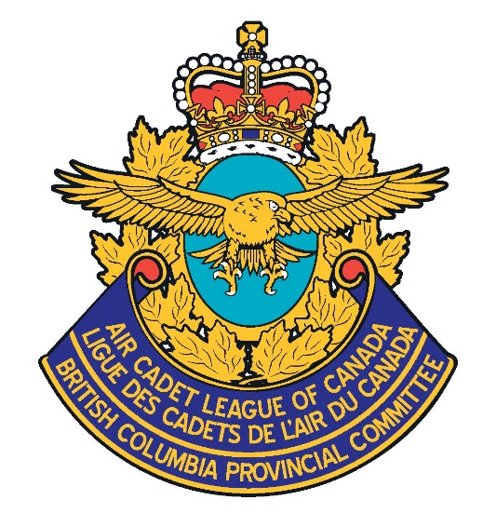

**Volunteering**

**with**

**Air Cadets**

#### FUN FACTS

**Who can volunteer?**

Anyone over the age of 18 can volunteer to help.

**Do I get paid?**

This opportunity is strictly for volunteers who want to help or give back to their communities.

**What do I need to join?**

All of our volunteers must undergo a Screening and Registration process.

**Do I have to give a certain amount of time?**

No. Based on what position you choose to volunteer in, you can help as often as you like.

**Do I need military or cadet experience**?

No, you do not need a background in the Air Cadet program or military. Our volunteers often learn best by experiencing the program as they go. They will be trained for certain jobs by other volunteers.

**How does this benefit me**?

Without our volunteers, this program would cease to exist. By helping out, our Cadets and community benefit.

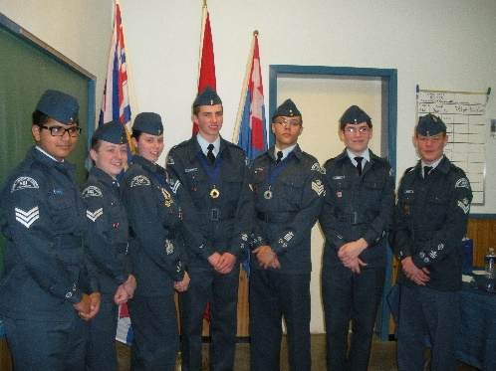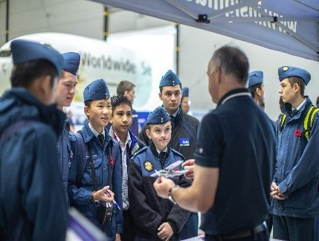

Fun!

Rewarding!

Challenging!

Memorable!

(SSC CONTACT)

Volunteers are an integral part of the partnership

in this program!

**#2 - 7630 Montreal Street**

**Delta, BC V4K 0A7**

[bcpc@aircadetleague.bc.ca](mailto:bcpc@aircadetleague.bc.ca)  
  
BCPC Office: 604-732-9119

Toll Free: 1-866-614-BCPC (2272)  
  
Fax: 604-732-9115

**Call or email for more information!**

**OR**

**Contact an Air Cadet Squadron**

**in your area.**

**Air Cadet League**

**of Canada**

**British Columbia Provincial Committee**

#### Director or Member

#### Volunteer

#### Squadron Sponsoring Committee

Volunteers work at the local Squadron level and support the Squadrons in various ways. Often the Volunteers are parents of current and former Cadets.

**There are several ways a Director or Member can support the organization.**

**Provincial Director**

Directors and Members must be nominated and approved as volunteers to help support their Provincial Committees.

These Volunteer positions are a must-have at a Squadron. The Squadron Sponsoring Committee (SSC) operates the business function of the Squadron.

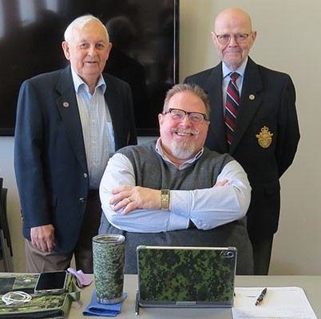

**Possible positions**:

* Canteen Organizer
* Fundraising
* Volunteer Drivers
* Event Supporters
* Effective Speaking Trainers
* Biathlon Instructors
* First Aid instructors
* Tag Days Volunteers

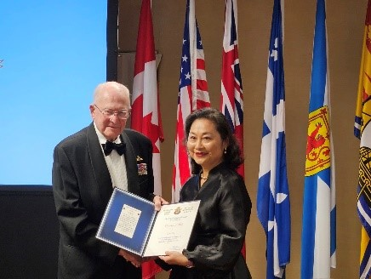

**Positions Available**:

* Chairperson
* Vice-Chairperson
* Treasurer
* Secretary
* Member

These positions require regular (minimum) monthly meetings.

The SSC has the responsibility to provide a training location for Cadets, paying the bills, fundraising, and providing necessary paperwork and recruiting for the Program.

All SSCs are incorporated Societies, and as a Screened and Registered Member of the Society, an individual is protected under the Society umbrella and (also) covered by Liability Insurance through the Air Cadet League of Canada.

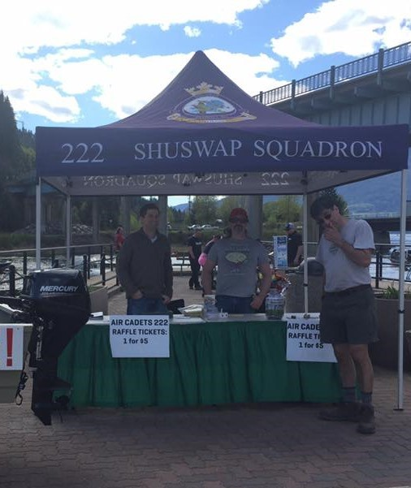

**League Representatives** are Members who liaise between the SSC and the Provincial Committee. These Members are resources for the SSC. They have the ability to teach volunteers.

**Members-at-Large** are able to support the Air Cadet League in various capacities. While they are not responsible for a particular Squadron, they may be responsible for contributing to other aspects of the Program.